Software Engineering Tools Lab

Assignment No-1

(Module 1- Introduction to OSS)

PRN-2018BTECS00009

BATCH-T3

1. Weka is a GUI workbench that empowers data wranglers to assemble machine learning

pipelines, train models, and run predictions without having to write code.

Using Weka tool perform below tasks such as data preprocessing, data classification (use

any appropriate ML algorithm) and data visualization efficiently on given dataset.

Use the Iris dataset givenhttps://drive.google.com/file/d/1A3Fxsfzm6BSfhFZGDrjI47RTe45bSgYP/view

Note-provide screen shots for every task

Create a report which will illustrate the details of tasks performed (for e.g to perform

preprocessing of data provide details of navigation and selection of appropriate parameters)

ANSWER-

1.INSTALLATION OF WEKA

STEP1- DOWNLOAD AND RUN

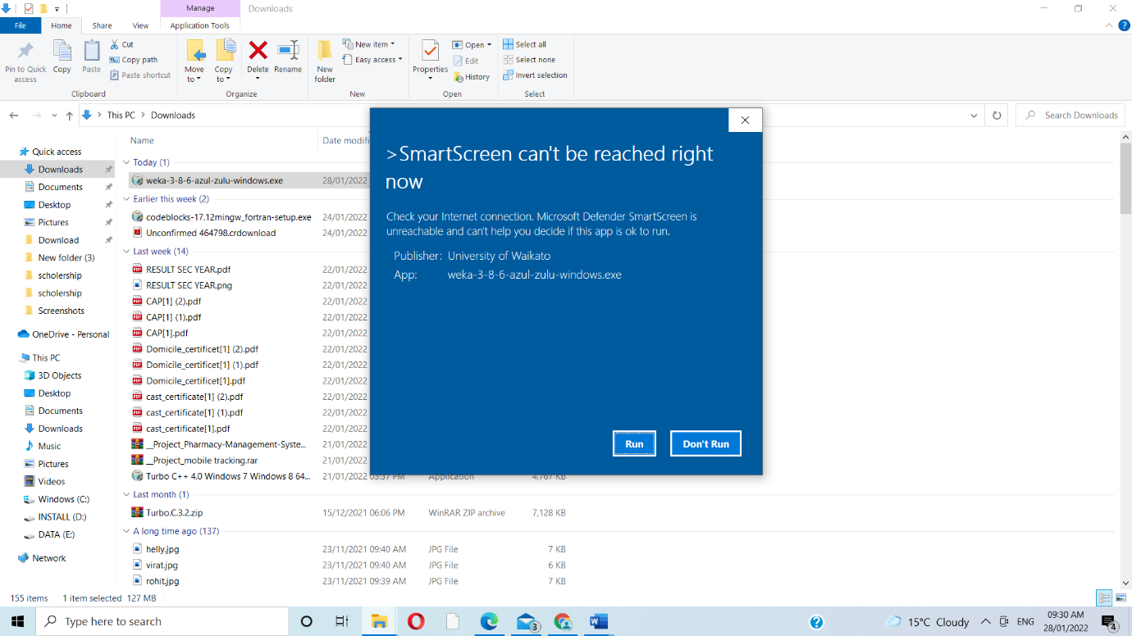

STEP 2- SETUP WIZARD

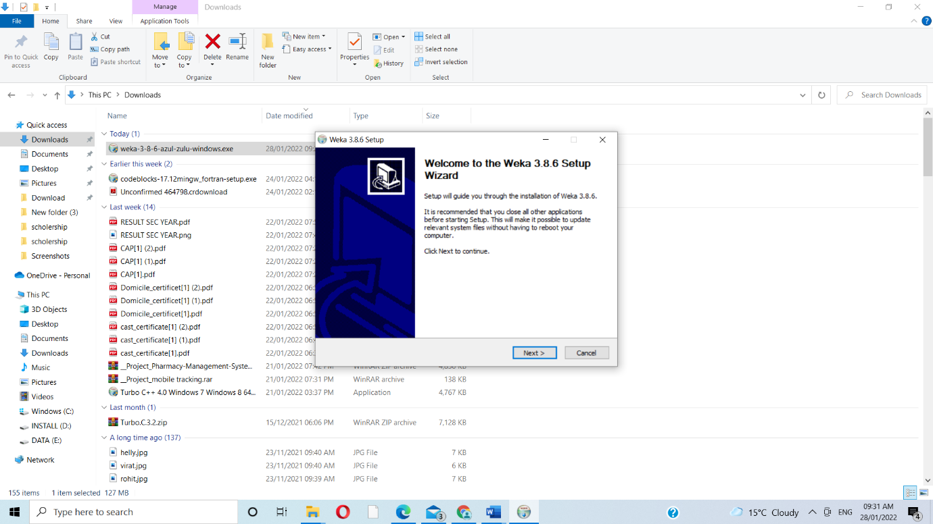

STEP 3- LICENCE AGREEMENT

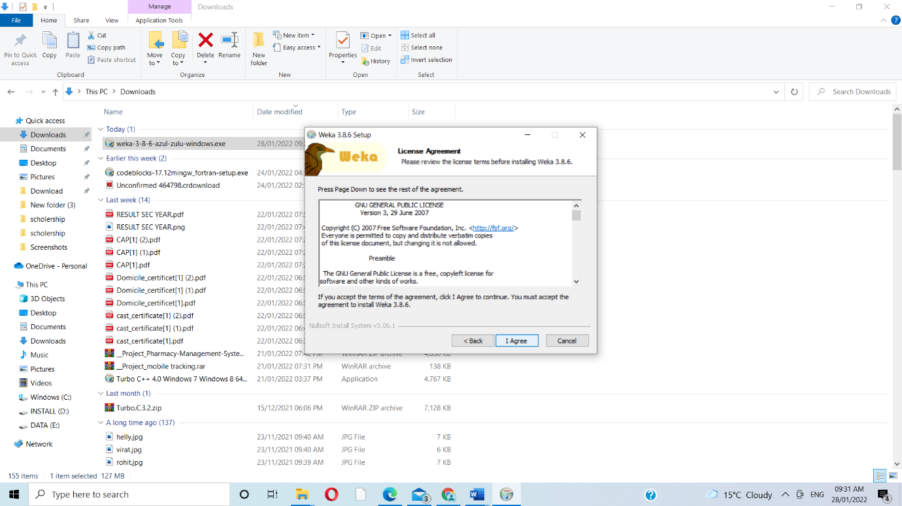

STEP 4-CHOOSE COMPONENT

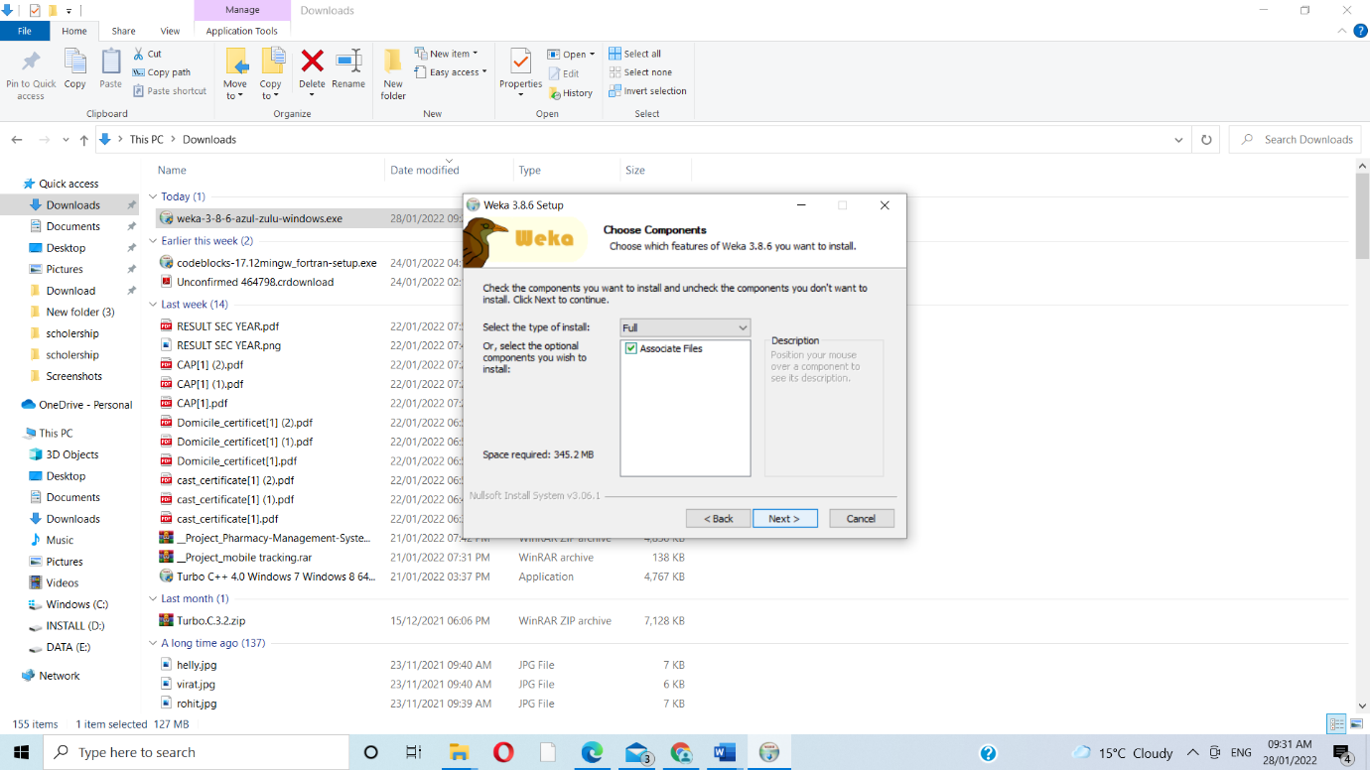

STEP 5- CHOOSE INSTALL LOCATION

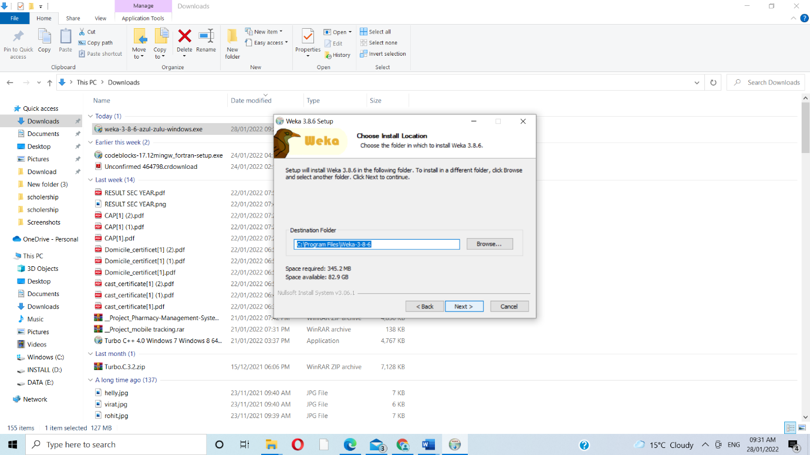

STEP 6- CHOOSE START MENUE FOLDER

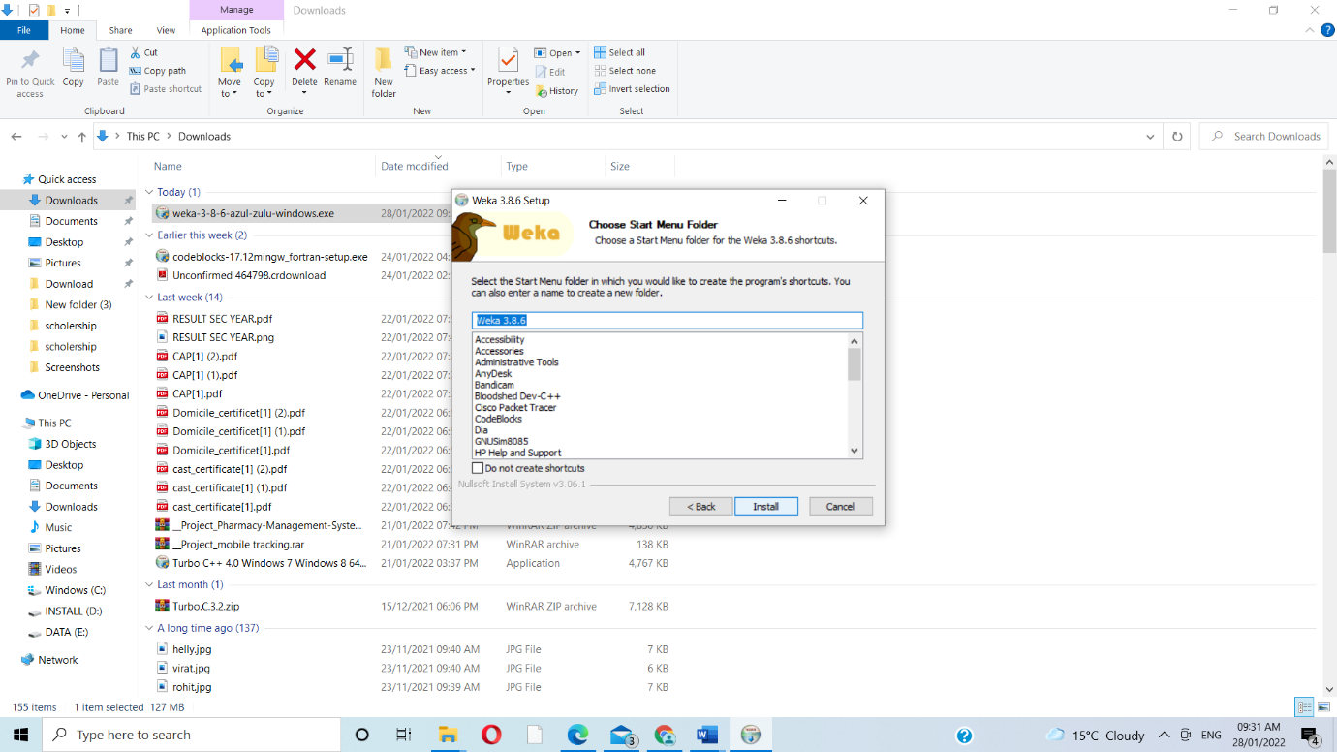

STEP 7- INSTALLATION

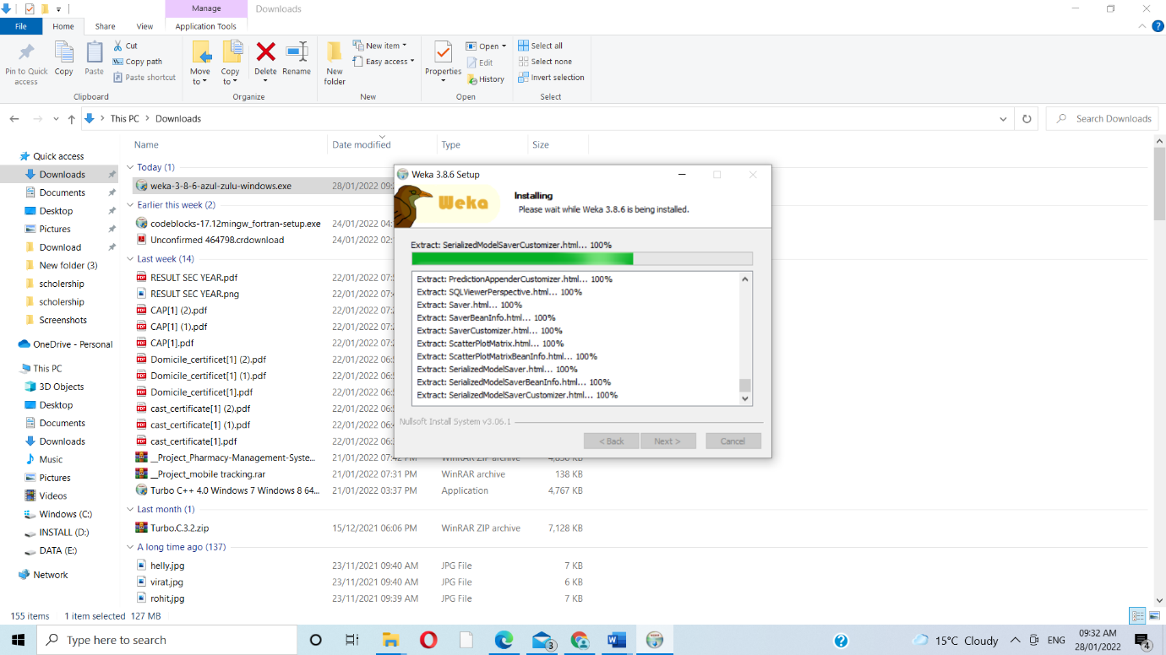

STEP 8- FINISH THE INSTALLATION

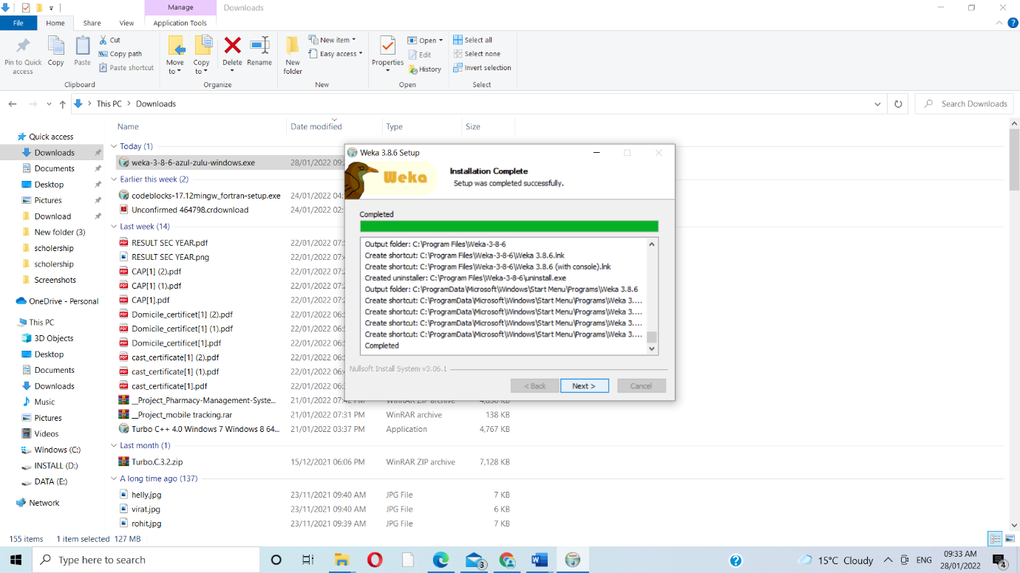

STEP 9-COMPLTE WEKA SETUP

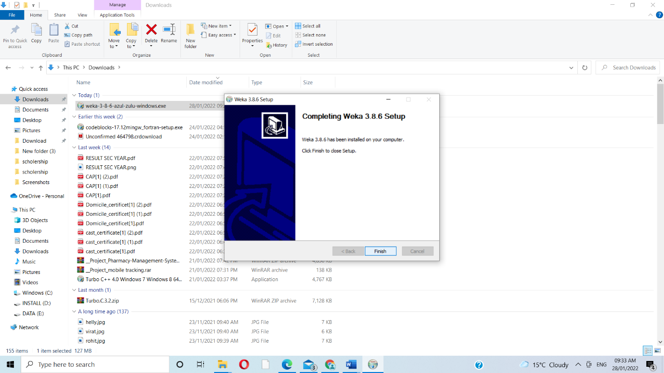

WEKA TOOL PERFORMANCE

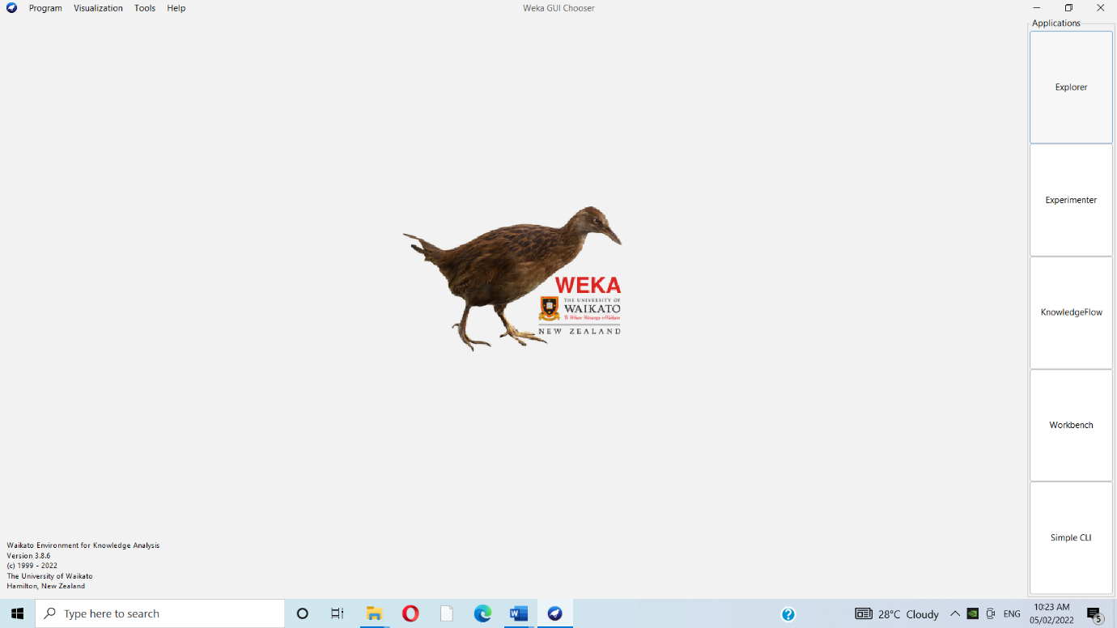

1.DATA PREPROCESSING

) WEKA — Preprocessing the Data

Open file ... option under the Preprocess tag select the .Iris file then screen shows us several things about the loaded data,

Goto the preprocessing section of the explorer part and there we can see aatributes name on left side

1.with all attributes

a)sepalllegth

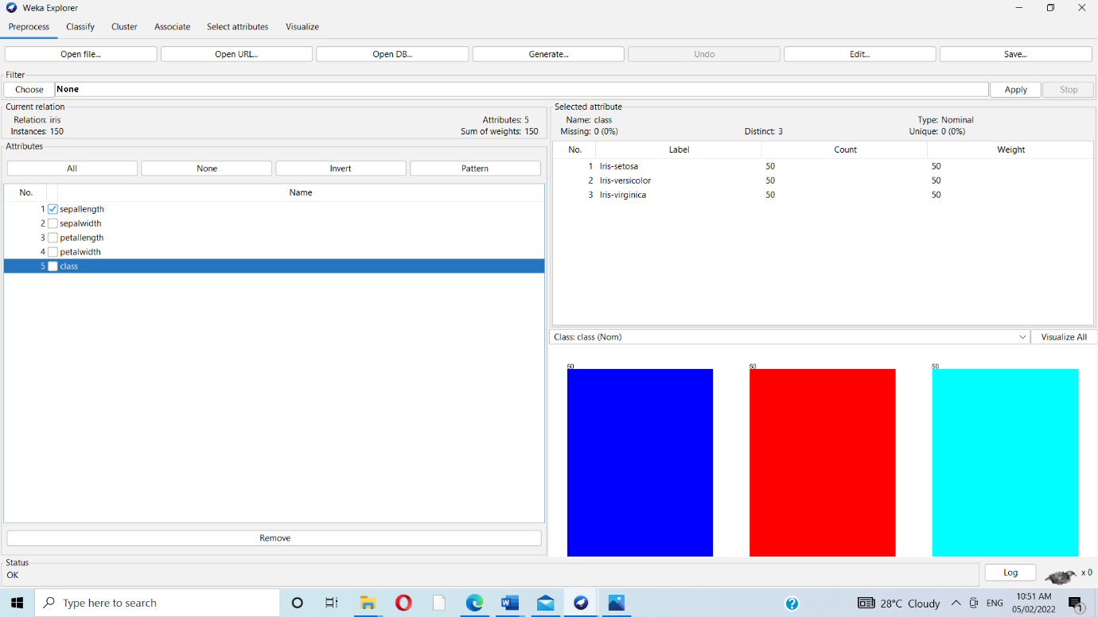

b)sepalwidth

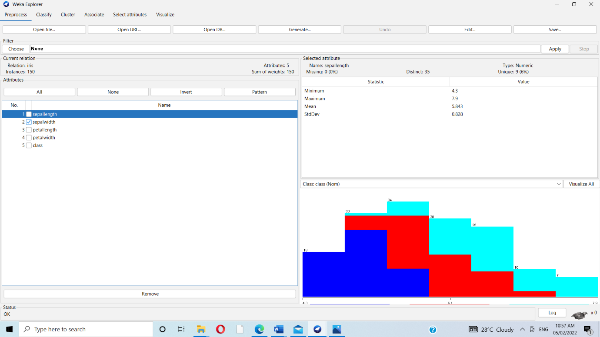

C)petallength

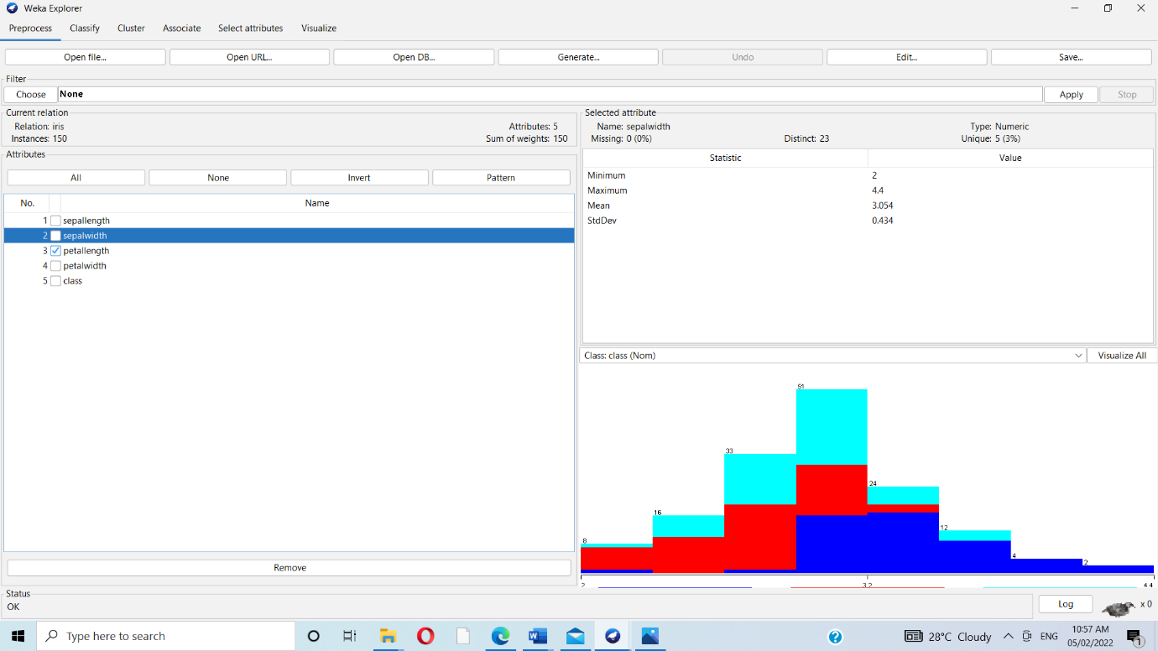

d)petalwidth

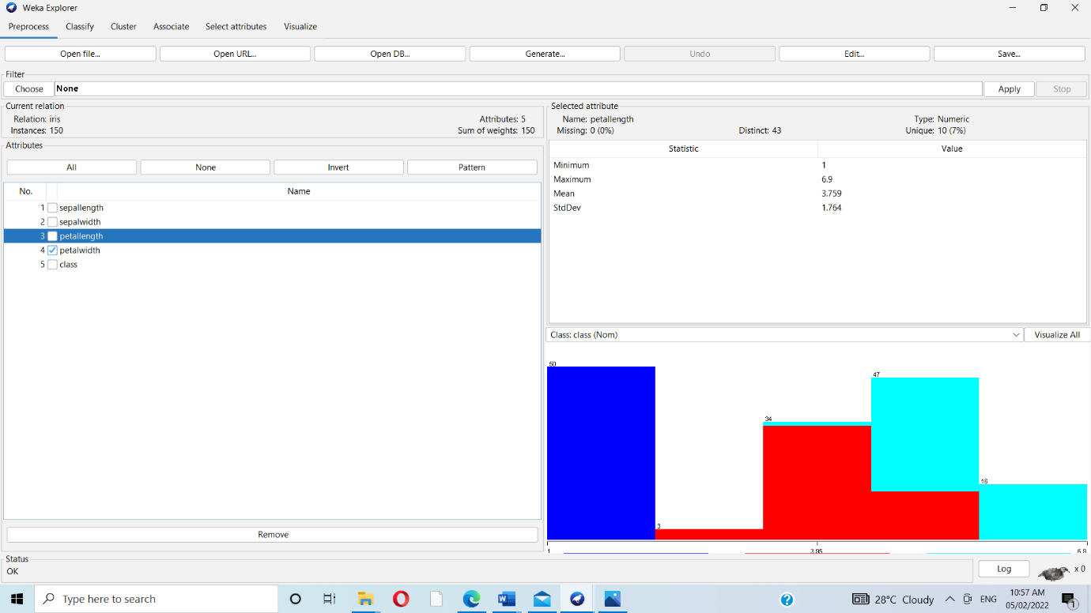

e)class

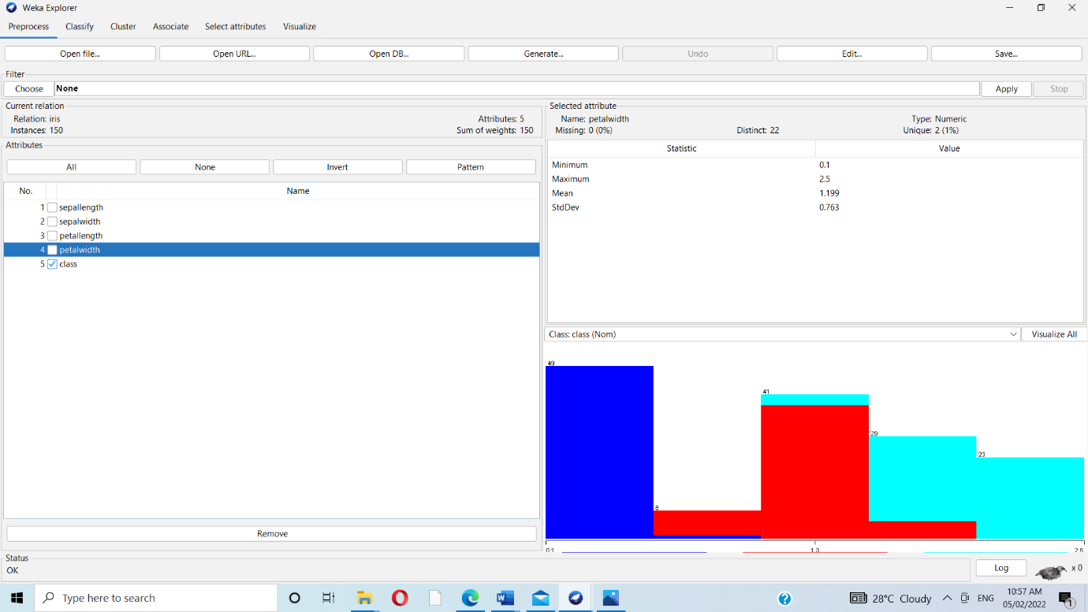

F)Visualize all

If you click on the Visualize All button,

you will be able to see all features in one single window the bottom of the window

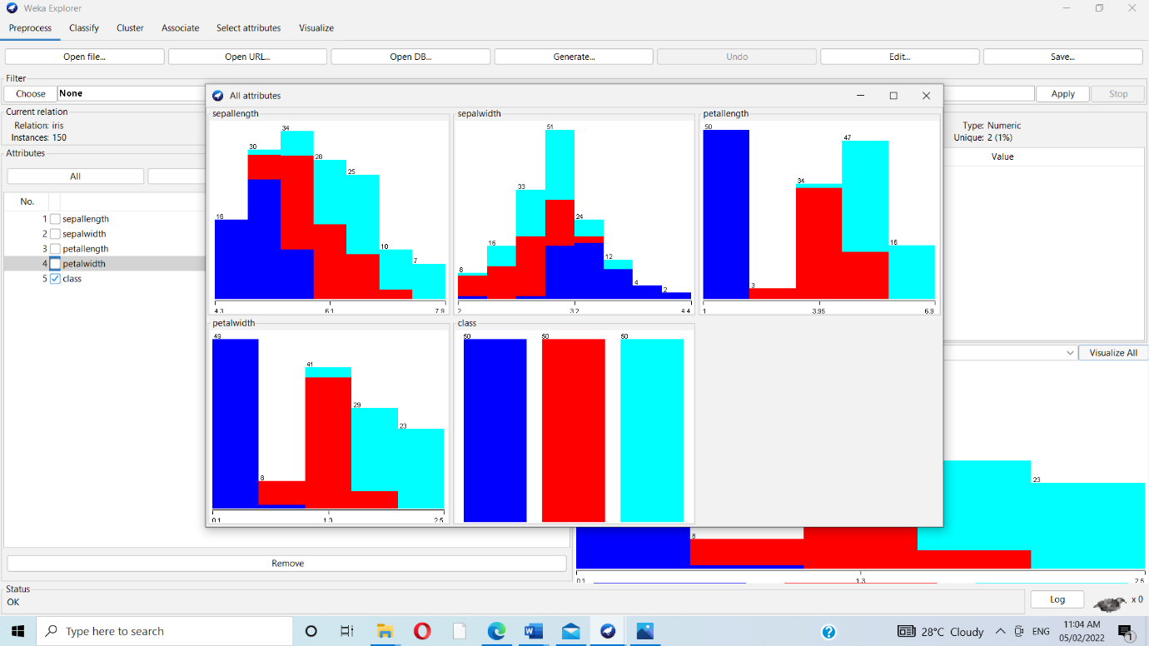

2.DATA CLASSIFICATION

Open file ... option under the Preprocess tab, click on the Classify tab,

Soo,there is a Test options. there four testing options as listed below:

Training set Supplied test set Cross-validation Percentage split

1.choose button and select the following classifier

Weka->classifier->trees->j48

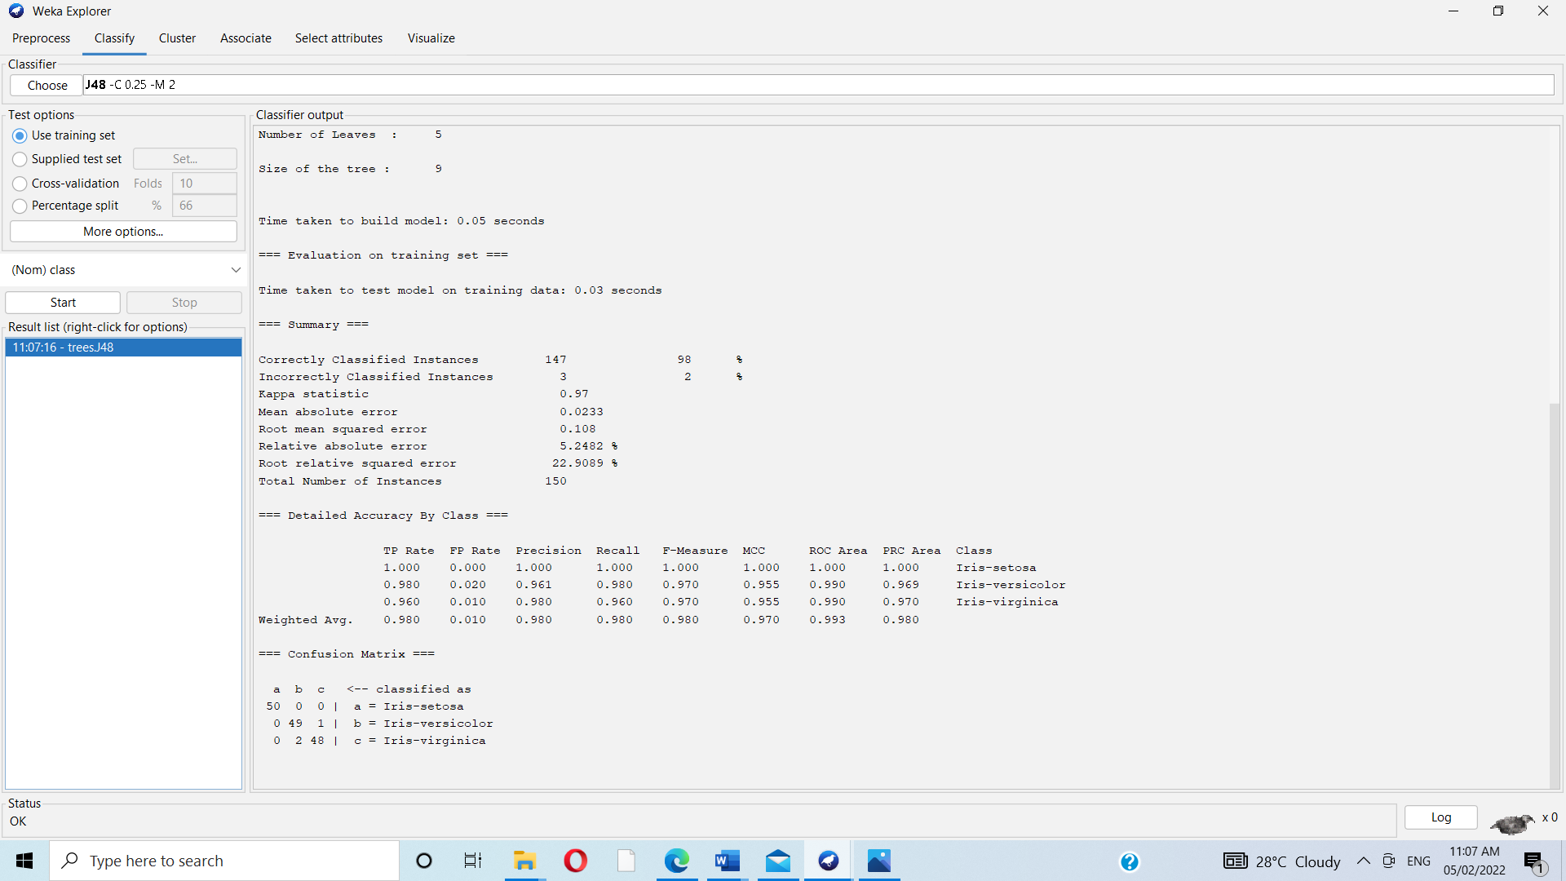

It say the size of tree 6.Also see the visual representation of the tree.In summery it says total number of instances as 150.

3.Data visualization-

To get the visual representation right click on the result in the result list

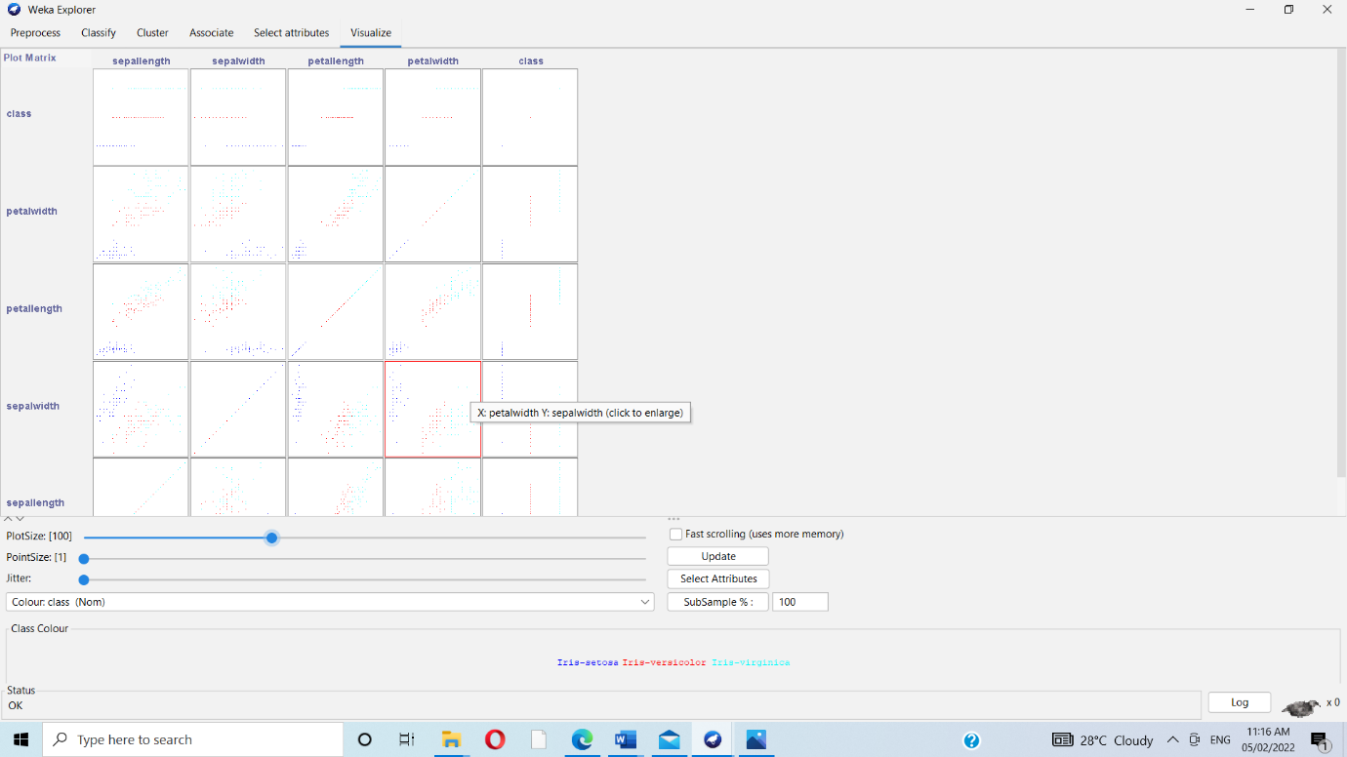

2. Orange is an easy to use data visualization tool with a large toolkit. In spite of being a

GUI-based beginner-friendly tool, you mustn’t mistake it for a light-weight one. It can do

statistical distributions and box plots as well as decision trees, hierarchical clustering and

linear projections.

1. Install orange

STEP 1-

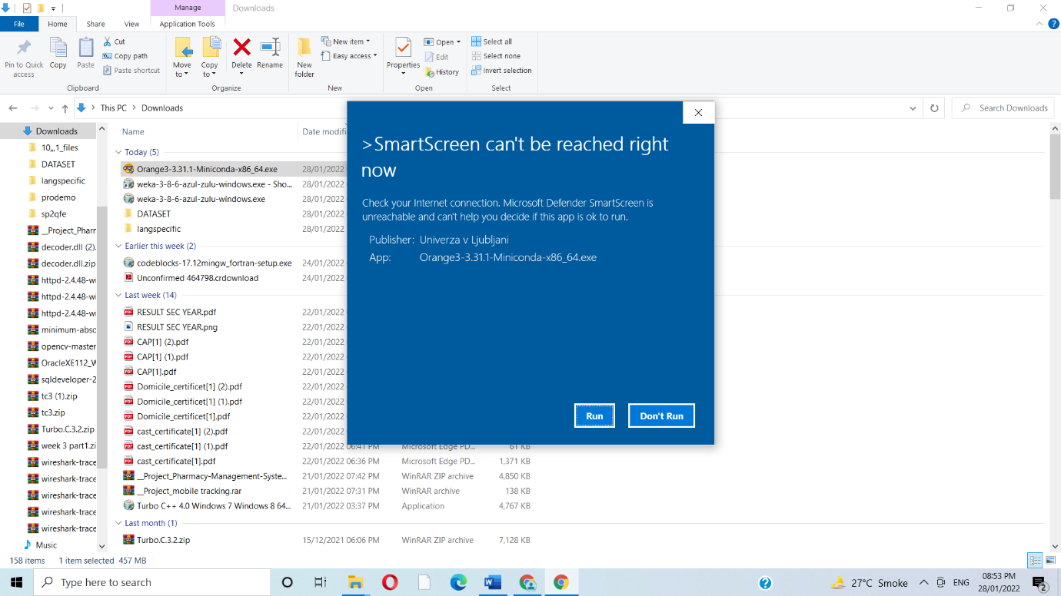

STEP 2-

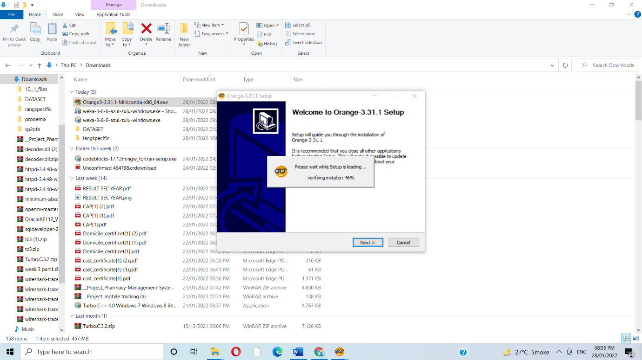

STEP 3-

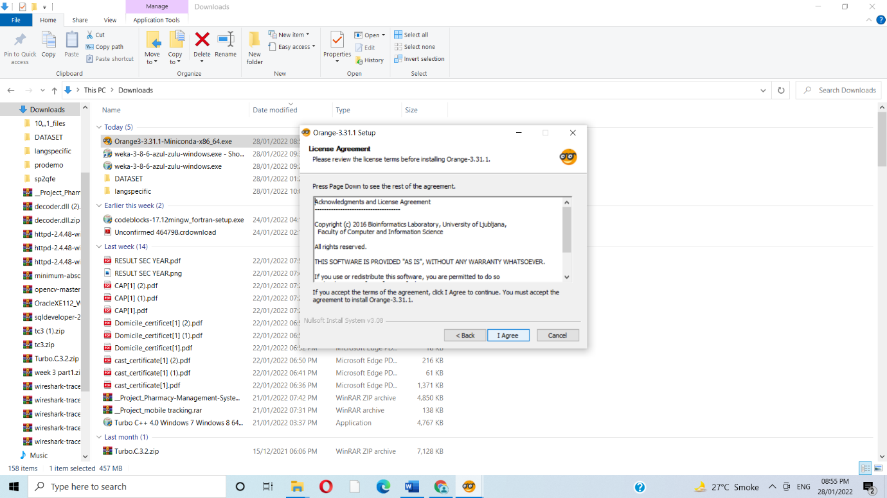

STEP 4-

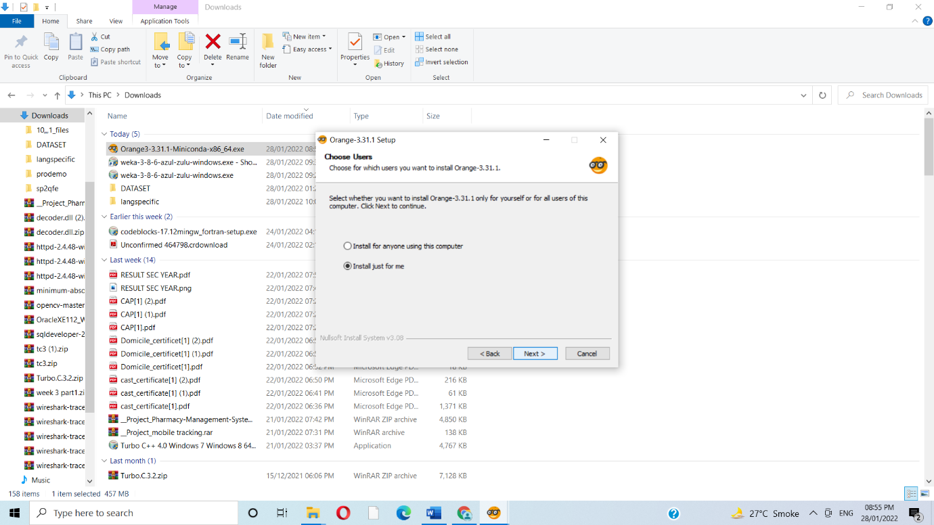

STEP 5-

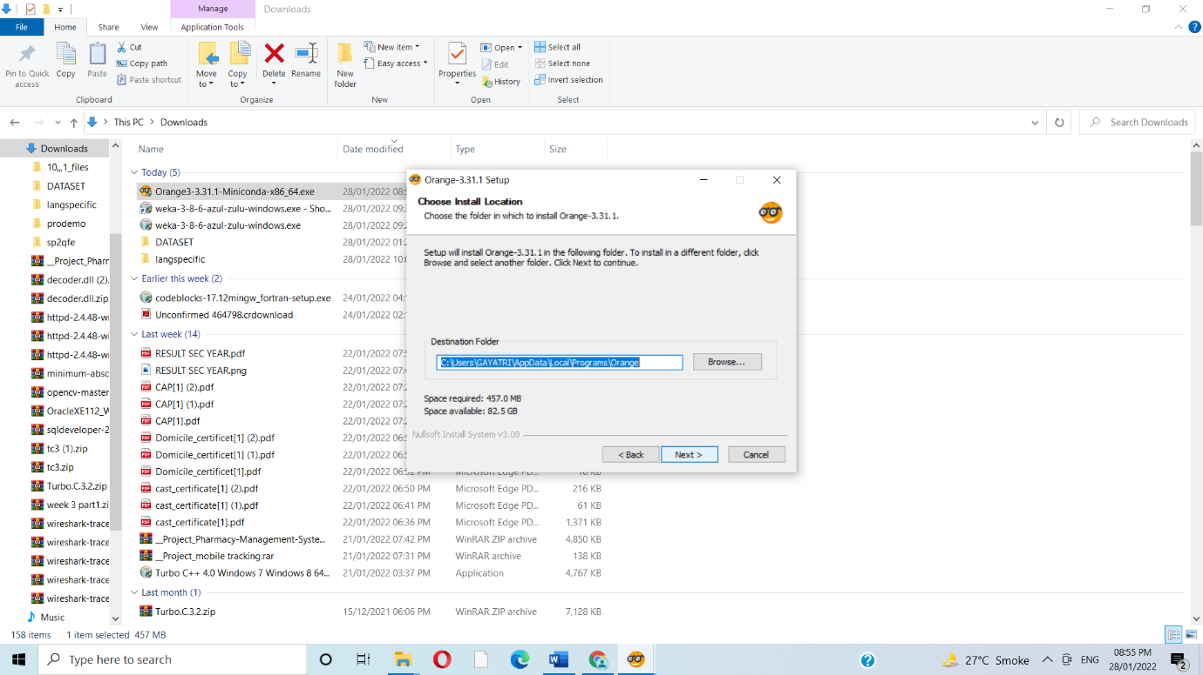

STEP 6-

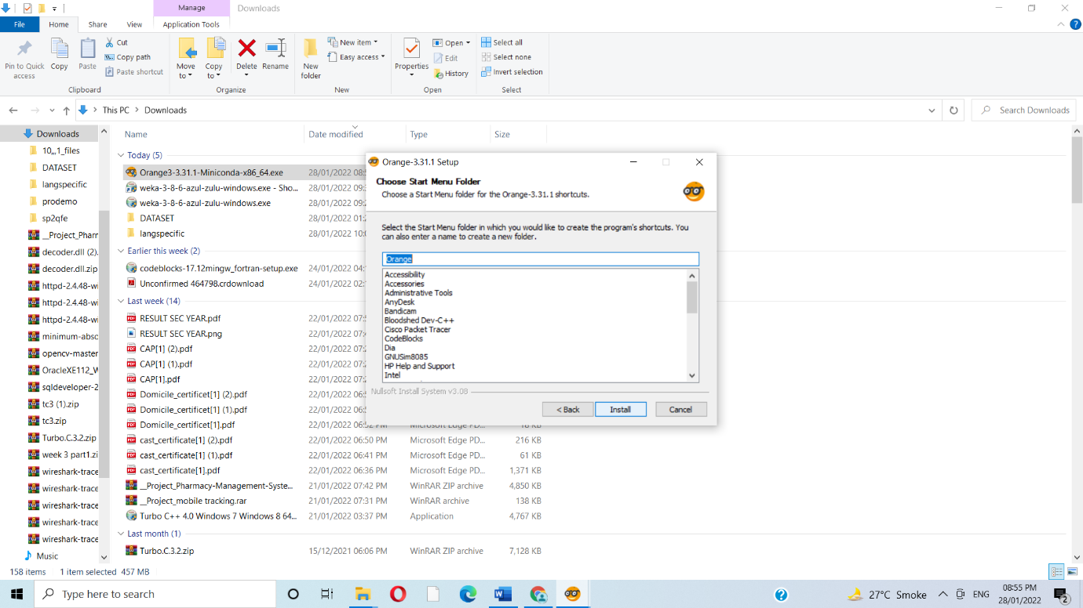

STEP7-

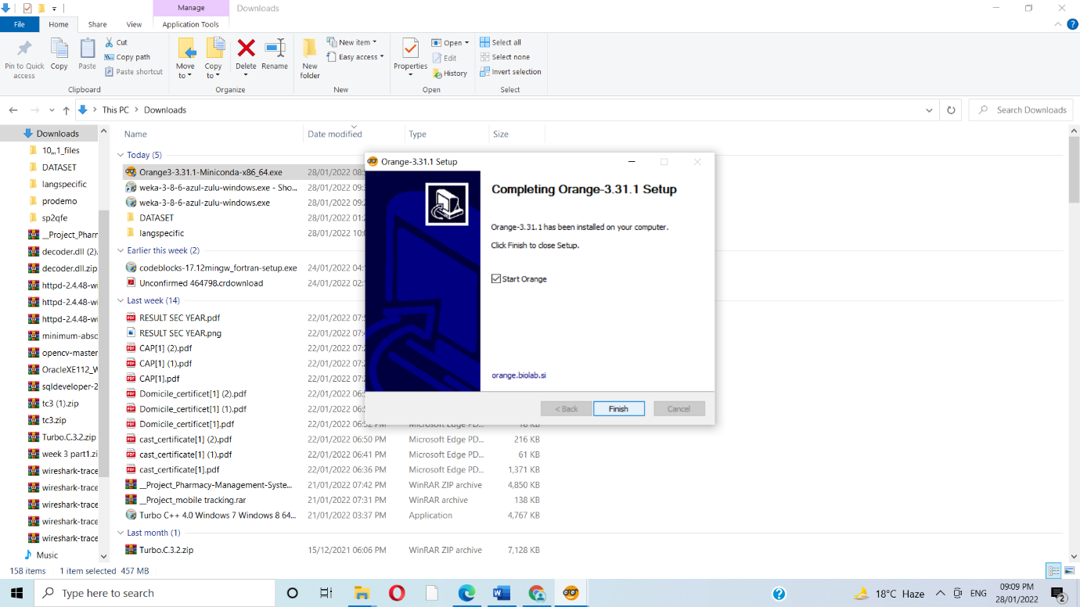

1. Show data distribution

We used the file widget to include our.csv file and then reviewed it using the data table widget.we can get the following distribution

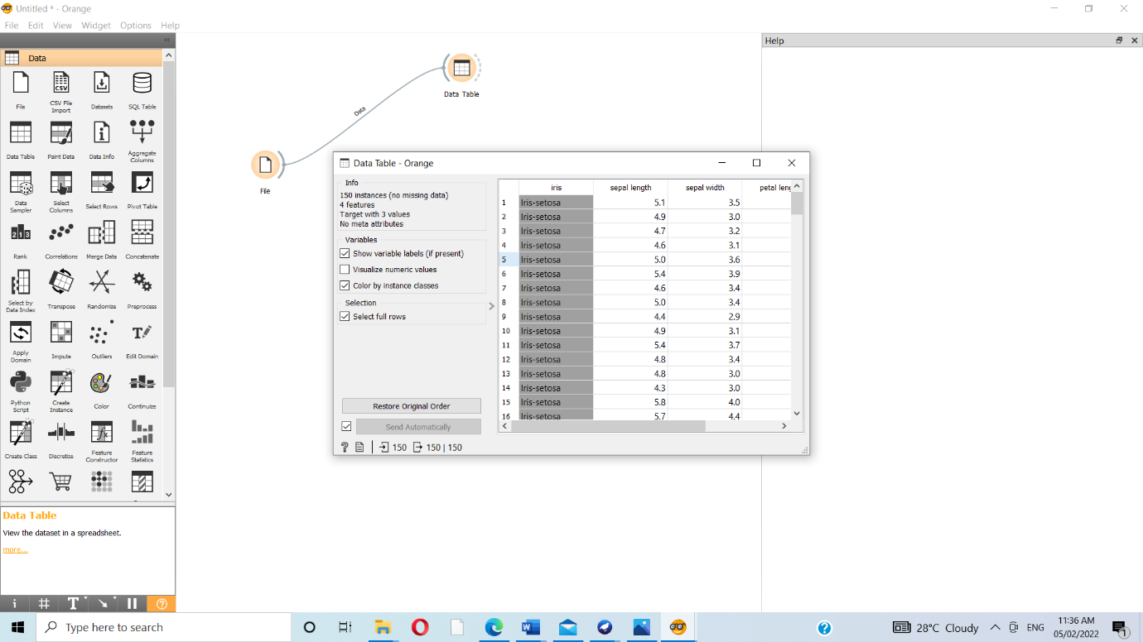

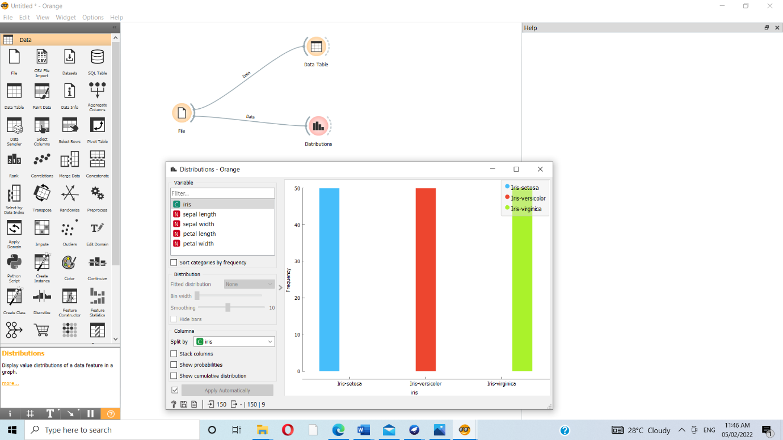

1. Show linear projection

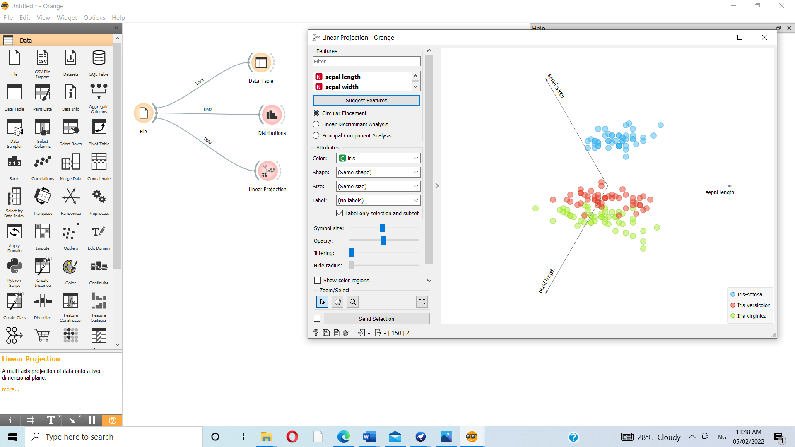

1. Show FreeViz

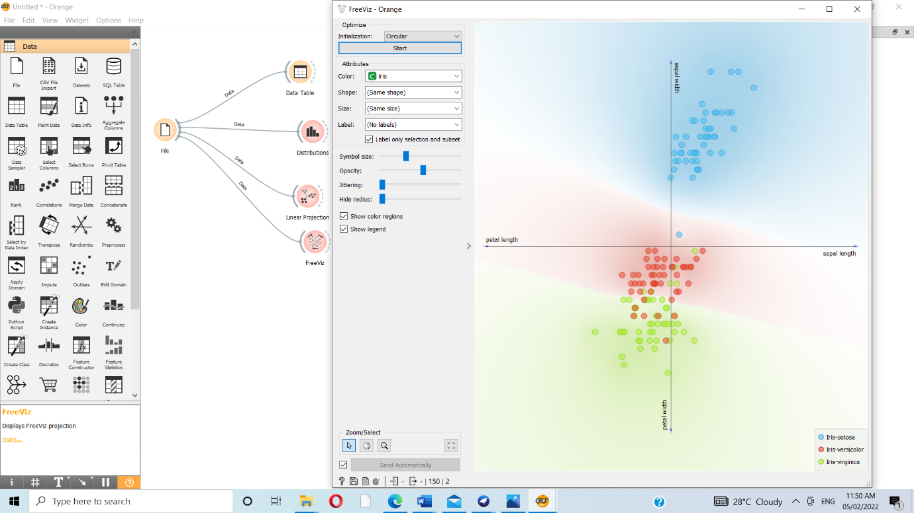

3. Differentiate in between free software, Open source software and proprietary software with respect to its properties.

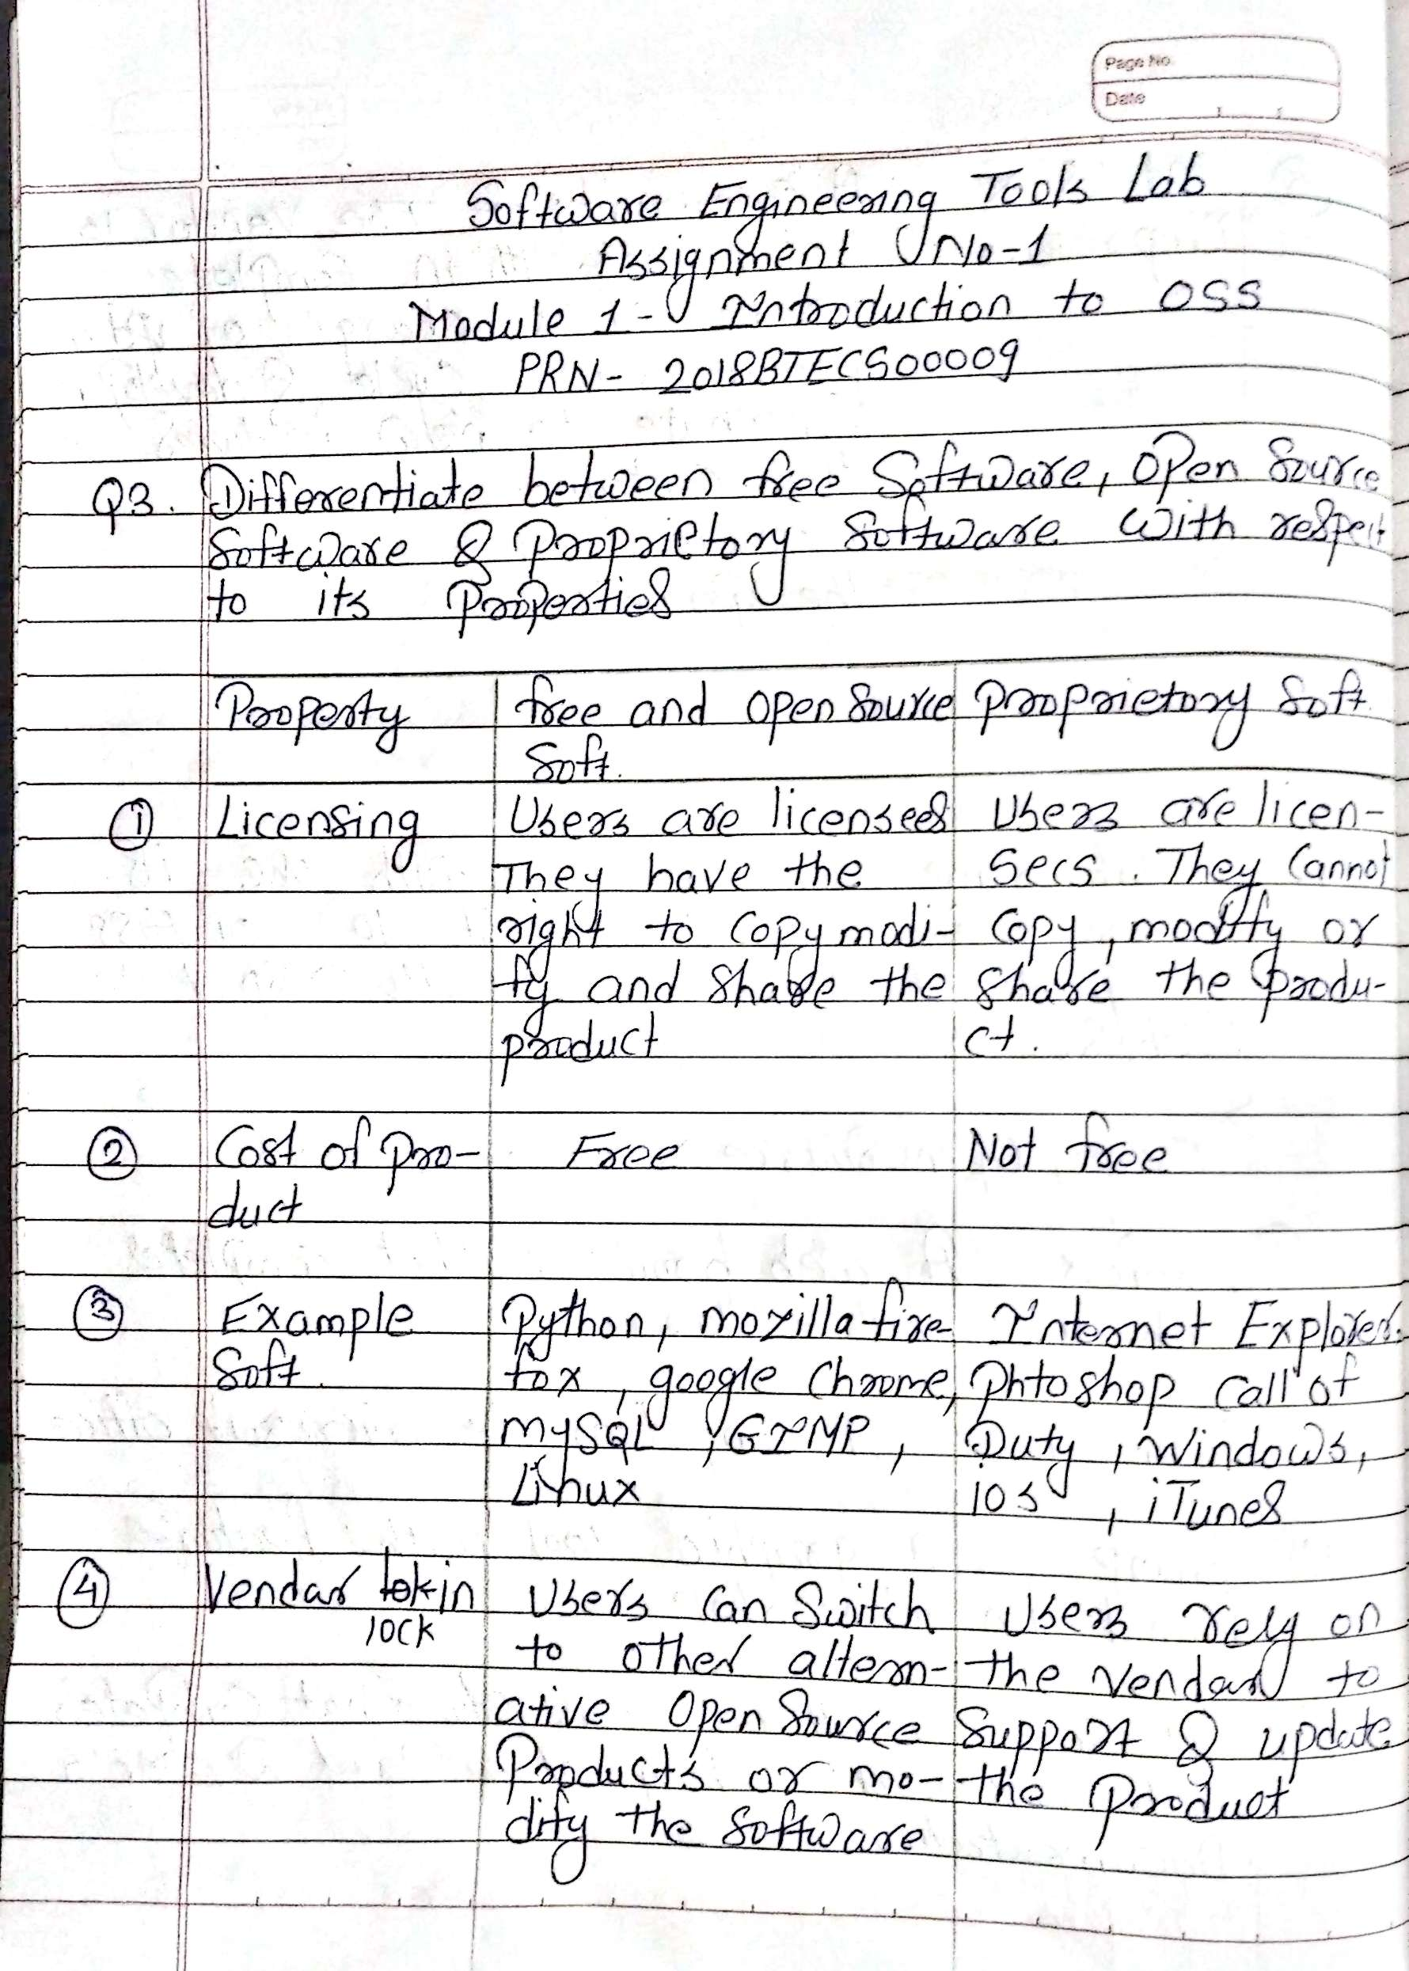

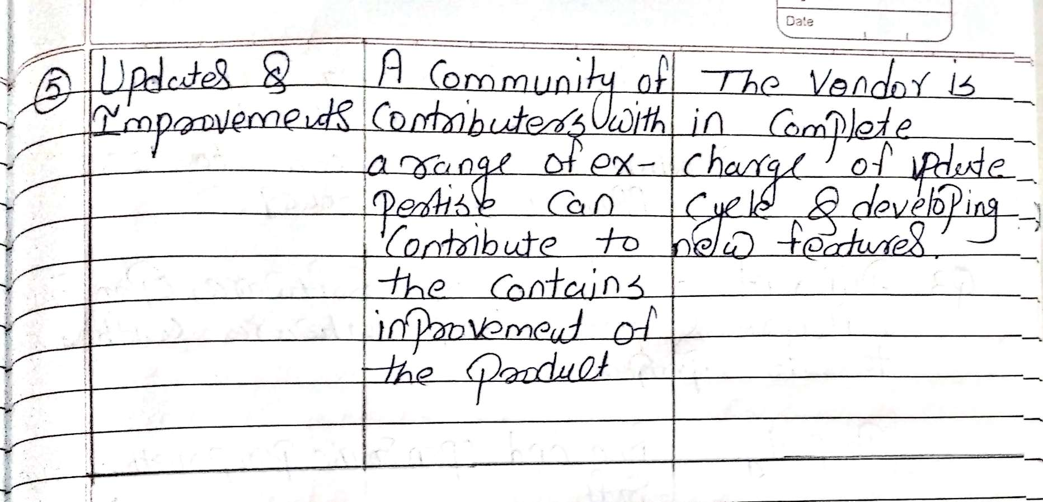

4. Using Anaconda Python create Histogram, Scatter plot and Bar plot for the dataset given below. Dataset- https://drive.google.com/file/d/1i11BZFe8Xj9kNq7eeE9KOa_Iz1KhEdXJ/view a. Scatter plot- Scatter plot of Price Vs Age b. Histogram- for Kilometer and CC c. Bar plot- Bar plot for different fuel types

STEPS OF INSTALLATION

STEP 1

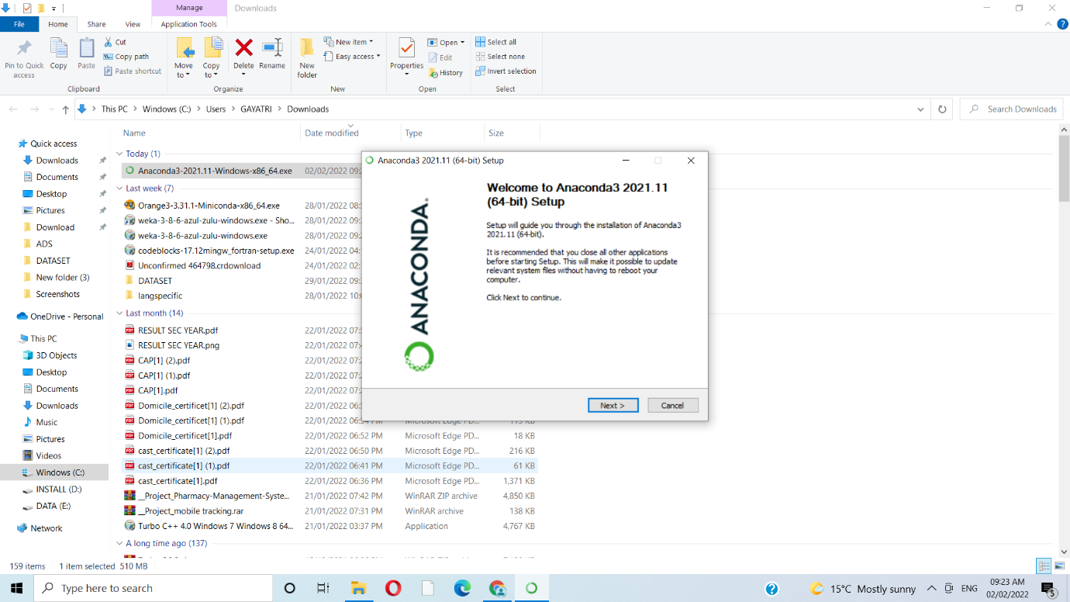

STEP 2

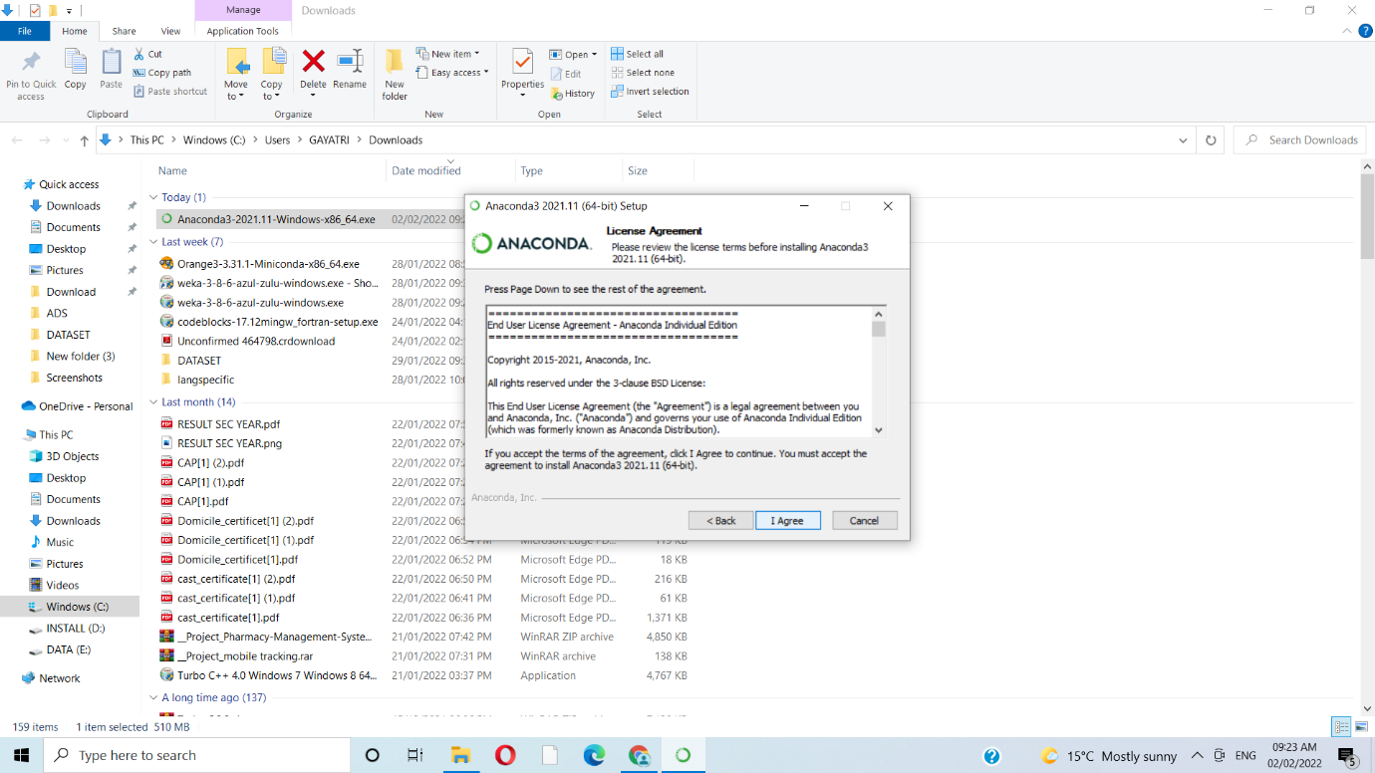

STEP 3

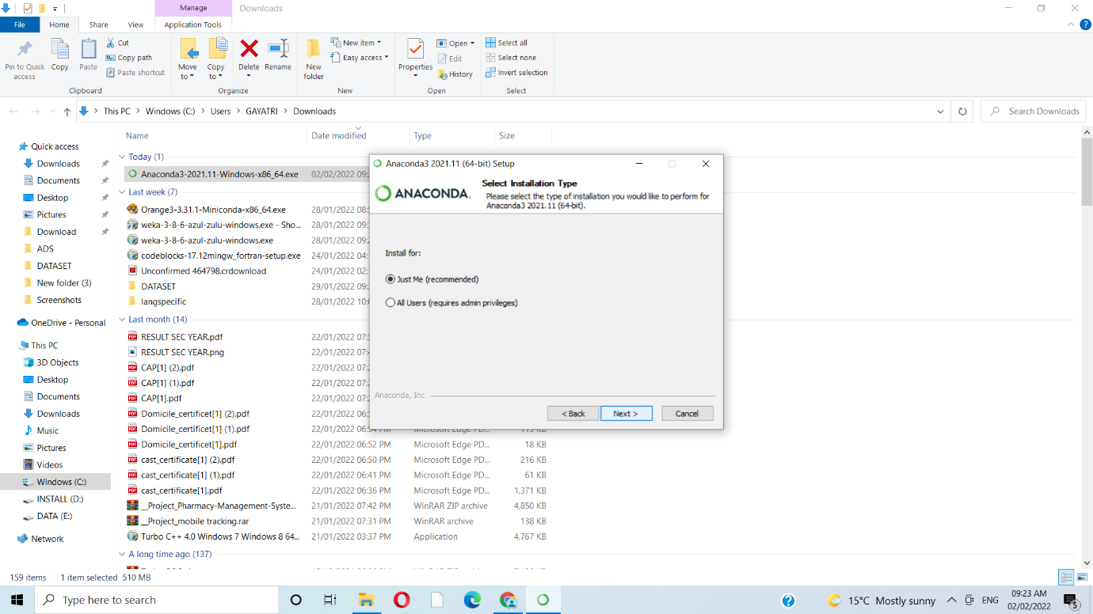

STEP 4

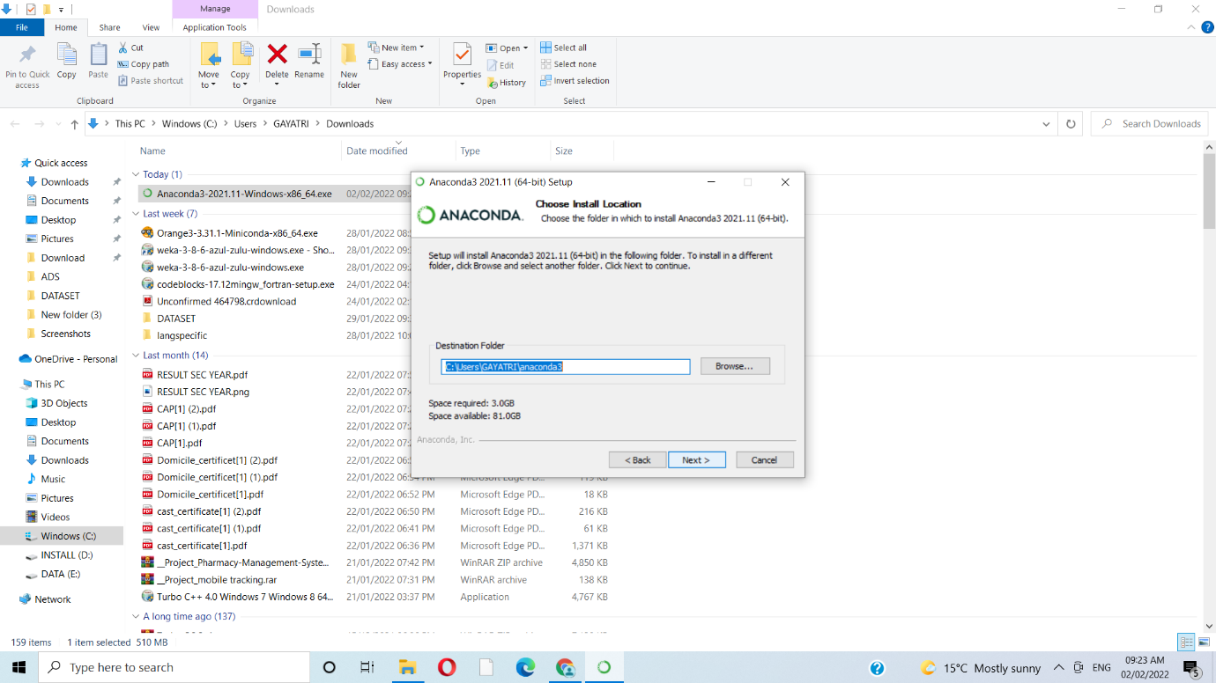

STEP 5

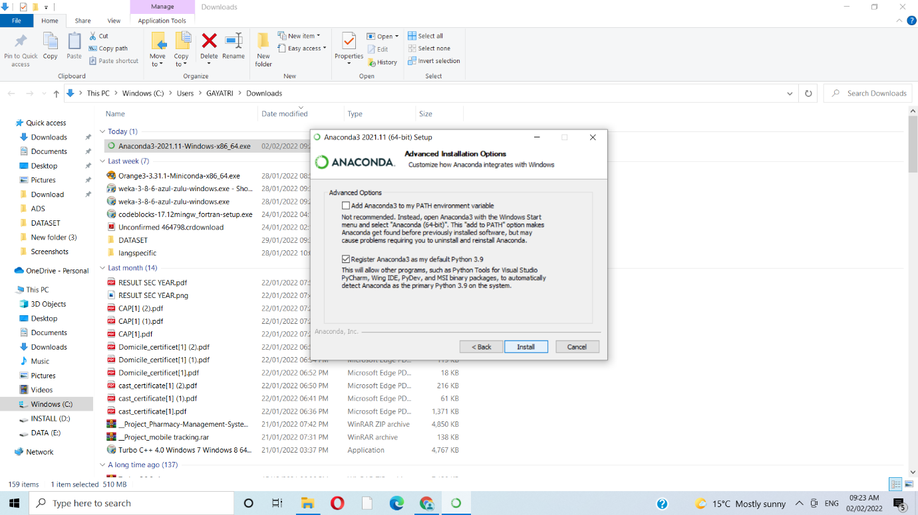

STEP 7

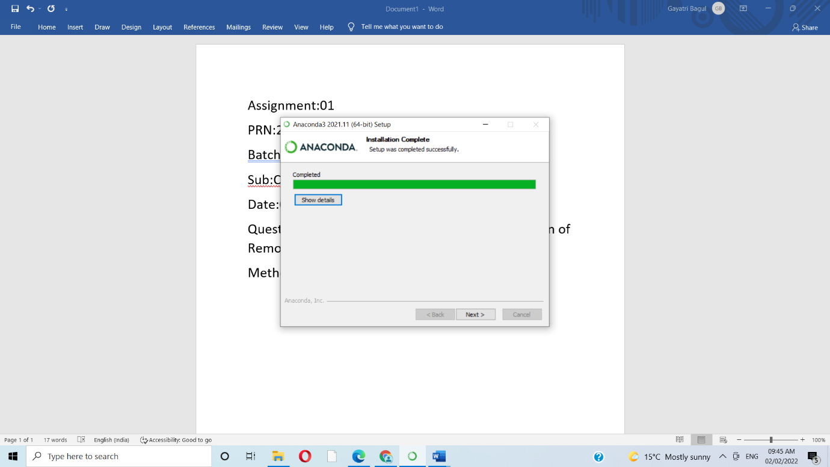

STEP 8

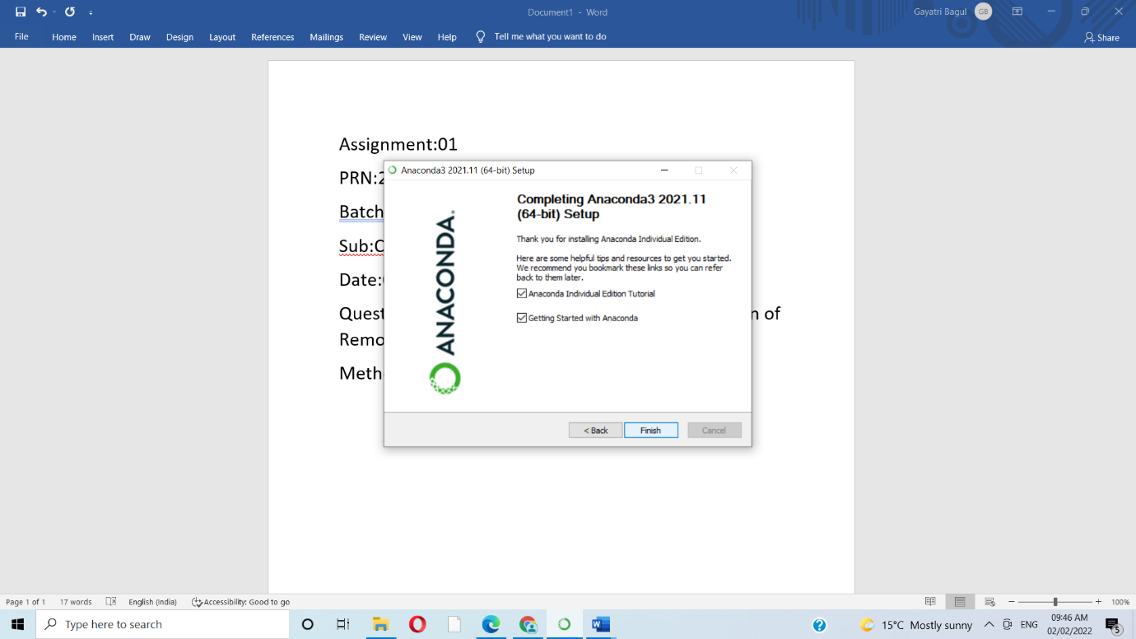

1.SCATTER PLOT

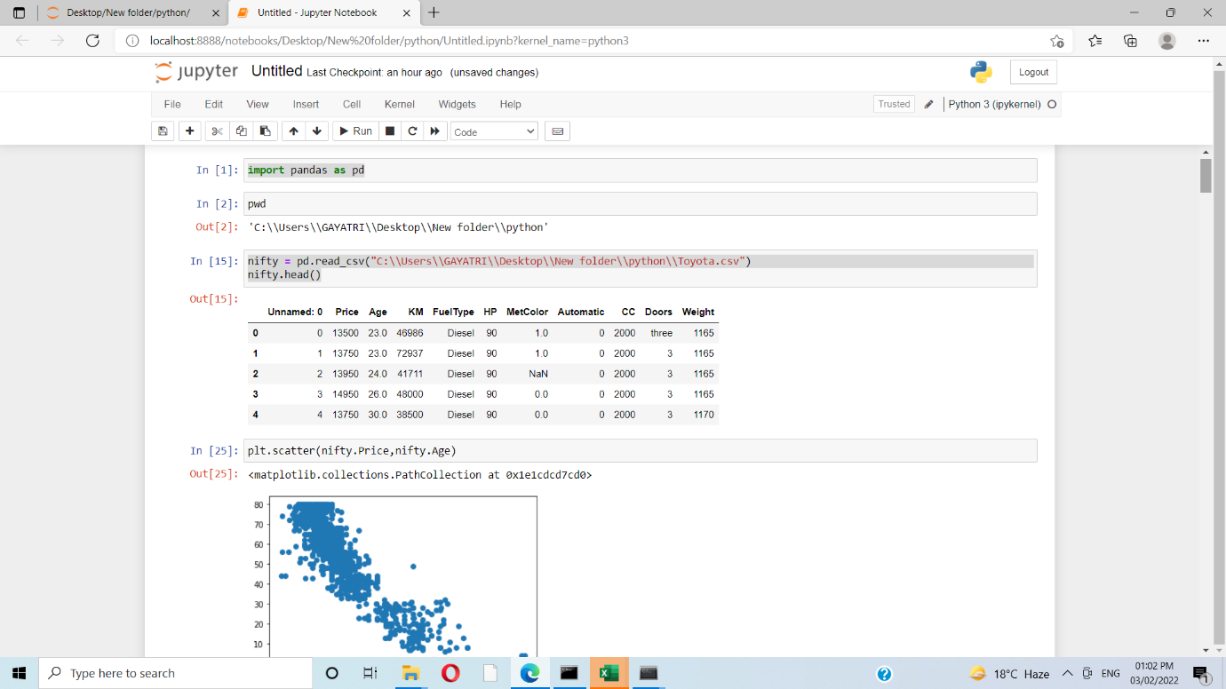

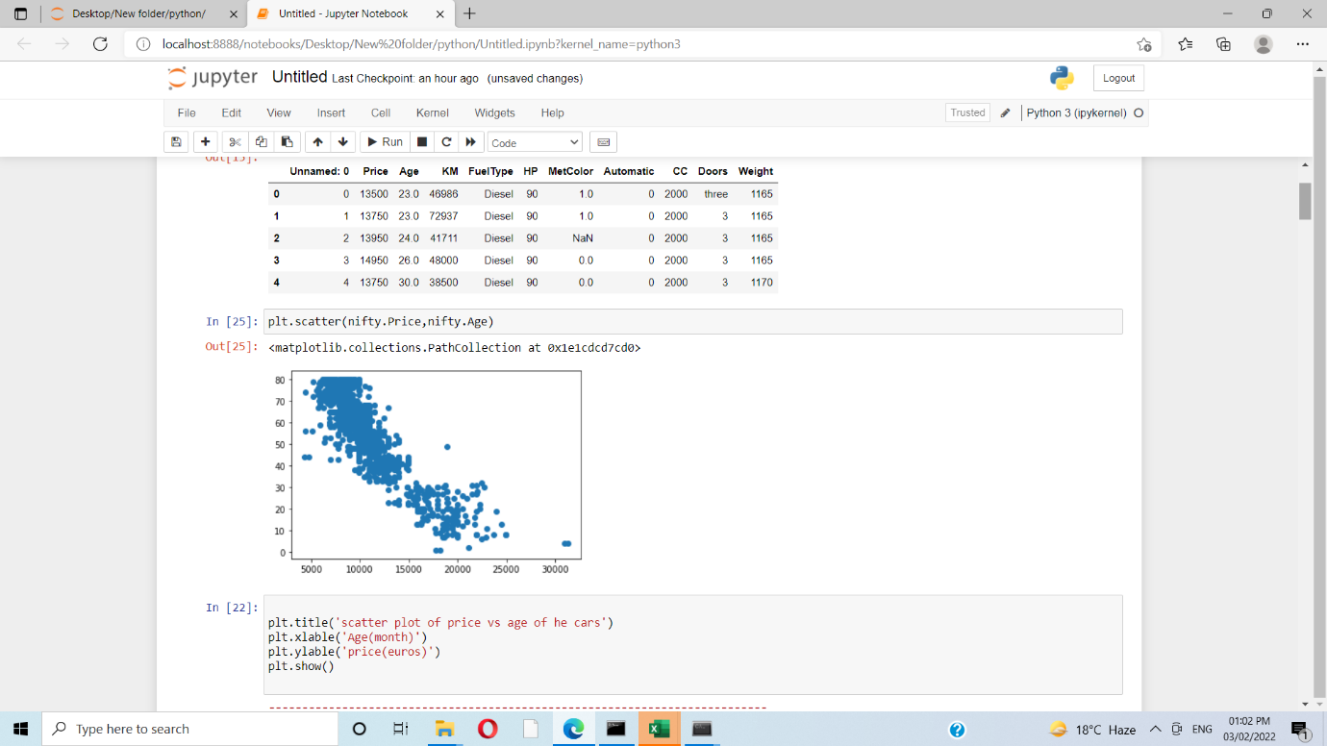

2.HISTOGRAM

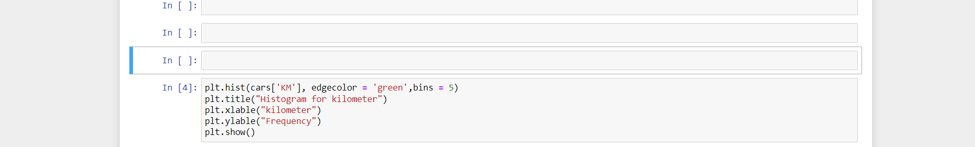

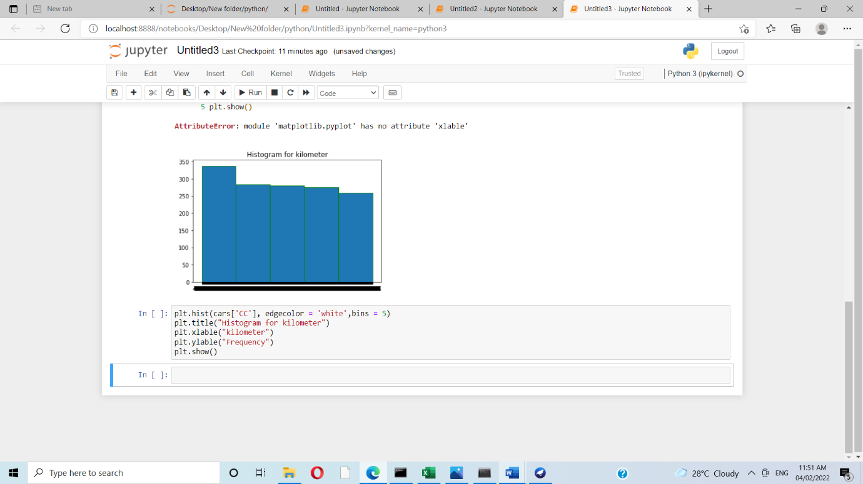

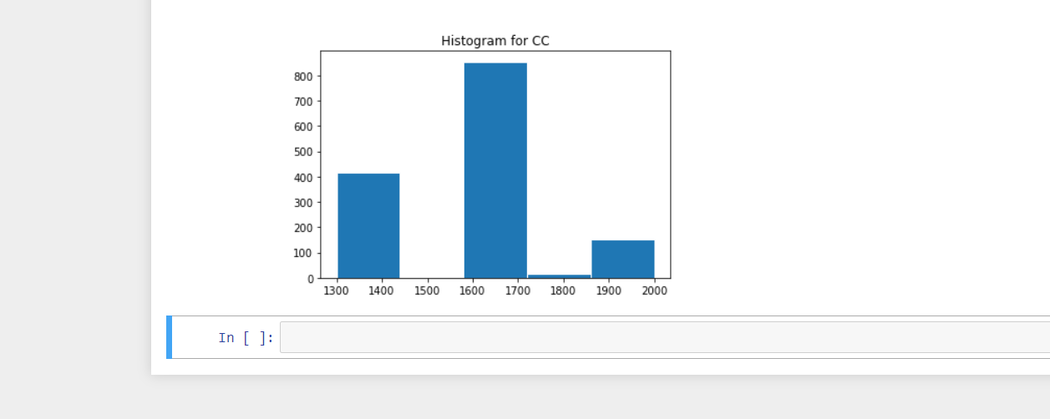

3.BAR PLOT

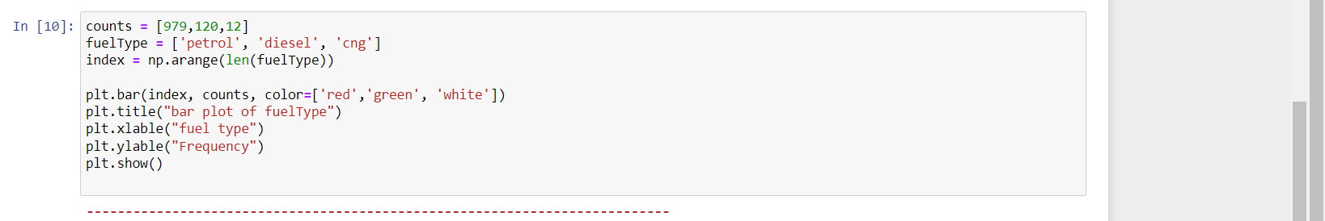

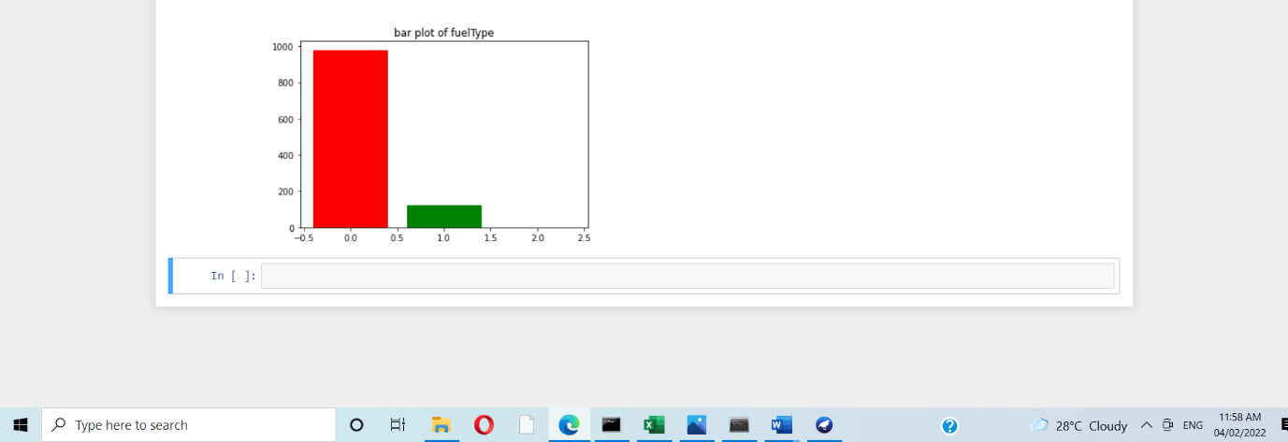

5. Enlist some examples along with its purpose and properties (at least 10) of FOSS and proprietary software with respect to database

